BASIC ACTIONS (ONLY ONES YOU NEED)
1) OPEN POWERSHELL
- Press Windows key
- Type: PowerShell
- Press Enter

2) START LINUX (WSL)
Paste:
wsl
If it works → prompt changes to
mda75@HWOFFICEPC:/mnt/c/Users/matth$
You are now in Linux, not PowerShell.

3) CONNECT TO A SERVER (SSH)

ssh root@134.209.186.176

- Type yes if asked
- Enter password if prompted
Digitalocan 2025Rootpassword75X

4) enter claude code
bash /root/start-claude.sh
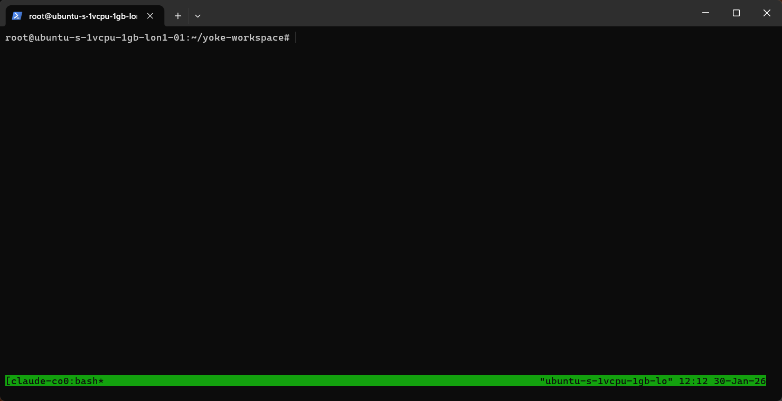
5) type in this to get to claude
claude

) EXIT OR RESET befor shut down.
From Linux:
exit
From PowerShell:
Exit
--------------------------------------
5) ONE-LINE RESET (MEMORISE)
If confused, always works:
- Close PowerShell
- Reopen PowerShell
- Paste:
wsl
Reboot kernal
apt update
apt upgrade -y
reboot

END

Browser interface for claude code
http://127.0.0.1:9090/?folder=/root/y
Password
C9Kl3n96MtJ1phWZa2kNRdhK

